**FPT ACADEMY INTERNATIONAL**



## FPT – APTECH COMPUTER EDUCATION

**RHYTHM HOUSE**

|  |  |  |  |
| --- | --- | --- | --- |
| **Center Name** | | FPT – Aptech – HCM2  Address: 590 Cach Mang Thang Tam, District 3, Ho Chi Minh City | |
| **Instructor** |  | Ms. Le Mong Thuy |  |
| **Class** |  | T1.2208.A0 |  |
| **Group** |  | 4 |  |
| **Group members** | | **Name** | **Student ID** |
|  |  | Nguyen Trinh Duy An | Student1381860 |
|  |  | Pham Duy Khuong | Student1408045 |
|  |  |  |  |
| **Duration** | Start date | 14th November 2022 |  |
| End date | 14th December 2022 |  |

**This is to certify that**

**Mr.:**

Nguyen Trinh Duy An

Pham Duy Khuong

**has successfully designed & developed**

eProject: Rhythm House website

**Submitted by:**

Nguyen Trinh Duy An

**Date of issue: 14-Nov-2022**

**Authorized Signature:**

**TABLE OF CONTENTS**

****FPT – APTECH COMPUTER EDUCATION 1****

****TABLE OF CONTENTS**** ****2****

****ACKNOWLEGMENT**** ****3****

****SYNOSIS**** ****3****

****PROBLEM DEFINITION**** ****3****

****CUSTOMER'S REQUIREMENTS SPECIFICATIONS (CRS) 4****

****Business/Project Objective**** ****4****

****Hardware/ Software Requirements**** ****5****

****SCOPE OF THE WORK (IN BRIEF) 6****

****Architecture and design of the system 7****

****Diagram of the website 8****

****TASK SHEET REVIEW 1 9****

****SITE MAP 10****

****MOCK OF THE WEBSITE 1********1****

***1. Homepage 1******1***

***2. Product 1******2***

***3. Blog 1******3***

***4. About Us 1******4***

***5. Contact US 1******5***

***6. Service 1******6***

***7. Sign In/ Sign Up 1******7***

****TASK SHEET REVIEW 2 18****

WEBSITE DESCRIPTION ****1********9****

RESPONSIVE****28****

[****JAVASCRIPT DESCRIPTION****](#Javascript) ****30****

****TASK SHEET REVIEW 3**** ****47****

# ACKNOWLEDGMENT

On behalf of the team, I would like to express the most sincere thanks to everyone who gave support and helped our team make the project successfully. Firstly, the eProject Team at Aptech, who guide and help me. You provide us with the opportunity to work practically.

Secondly, our teacher who has supported us so much since starting learning at Aptech. We were able to complete this projected with her guidance. And finally, I also give thanks to remaining members of the team. Although there are two members on my team, we strive to support the other.

# SYNOSIS

# Objectives of eProject is give us a sample project to work in the real life projects. With help of knowledge studied at FPT Aptech, we must fulfil this lession by creating a Single Page Application. This SPA is build for Rhythm House that is a music store finding a easy source to reach to the customer, host all the information about their shop. They want to provide their customers with their product, event, album,… and also satisfy customers with discount programme, passionate staff,... And the site needs to be developed base on set of requirements

# PROBLEM DEFINITION

The Web site is to be created based on the following requirements.

1. The Home Page should display main informations.
2. Hearder, footer will be applied to all page.

3) The product page should display a menu to filter product.

4) The information should be categorized according to different type of products like if a User wants to see only ‘movie’ then he click on a Link/button/menu etc and he will see different type of ‘movie'. Similarly for the others.

5) When a user selects any product type, a list of products for that product type will be displayed.

6) There is a Point Calculation in membership page, also has a registry button.

7) There should be a “Contact Us” page which will have the Address of the Company and the mail address which when clicked will invoke the local mail client from where they can send an email. Address of the Company should be displayed using GeoLocation API (eg. GoogleMaps).

# CUSTOMER'S REQUIREMENTS SPECIFICATIONS (CRS)

**Client: Rhythm House**

### Business/Project Objective:

Looking at the growing competition, the customers have decided to find an easy source to reach to the customer and the solution they thought of is of building a web site which will host all the information about their shop.

They have approached you to develop site by the name rhythmhouse.com for them. The site needs to be developed based on the following set of requirements.

The website is to be developed for the Windows Platform using HTML5, JavaScript and Geolocation. The site should work well in all leading browsers including Chrome, IE, Firefox etc.

**Input to the system:**

- Enter to search products based on movie, band, solo performer, release year.

- Filter by category, type, year.

- Register members on website.

- Enter log-in informarion.

- Feedback about the quality of products.

**Output from the system:**

- Display results according to the search content.

- Album (movie/ band/ solo performance).

- Display the statistics of product sold monthly.

- Display product information by price, specifications, brand, image, model...

- Display the special information of the product.

- Display the available books and magazines.

- Display the details of liveshow, schedule of upcoming liveshows.

- Display the offers/contests by the shop.

- Site should be able to provide brief introduction/history about the shop under About Us page.

- The location of the shop under Contact-Us page.

- Displays FAQ and allows users to email directly to the company.

**Process**:

* + - * Validate data input from users.

**Expected delivery date:** 14-Dec-2022

**List of deliverables:**

- Document Word, PDF.

- User Guide.

- Source code.

### Hardware/ Software Requirements:

* **For developer**

**Hardware**

* + Intel Pentium 4 processor or higher
  + 01 Gigabytes of RAM or higher

**Software**

* + Windows 7 OS or higher
  + Adobe Dreamweaver
  + Web browsers such as IE, Chrome or Firefox are supporting HTML5, CSS3 and Javascript.
* **For web users**

**Hardware**

* + Intel Pentium 4 processor or higher
  + 512 Megabytes of RAM or higher

**Software**

* + Windows XP OS or higher
  + Web browsers such as IE, Chrome or Firefox are supporting HTML5, CSS3 and Javascript.

# SCOPE OF THE WORK

There are webpages our group has decided to be contained in official Rhythm House website. Each page is accessible to other pages.

1. ***Homepage***: Home page will have some pictures of Rhythm music house. It also display some main informations about orther page: product(Catefories, Album), blog(contest, live show), sold monthly.
2. ***Product***: There is a search button based on movie, band, solo performer, release year. Product page display the price list of available items in the shop. (CDs, DVDs, Tapes, Books, Magazines).
3. ***Membership***: Display benefits and offers for Rhythm House’s member, also calculate coupon base on point.
4. ***Blog***: Blog page will show available contests and live shows.
5. ***About Us***: Some information about rhythm house and team member building this website.
6. ***Contact Us***: Phone number, address, email will be provide. And a form for getting in touch.
7. ***Cart***: Display shopping cart – items sellected by user.
8. ***Log In/ Sign Up***: Allow users Sign-up & Log-in to the website.

# ARCHITECTURE AND DESIGN OF THE SYSTEM

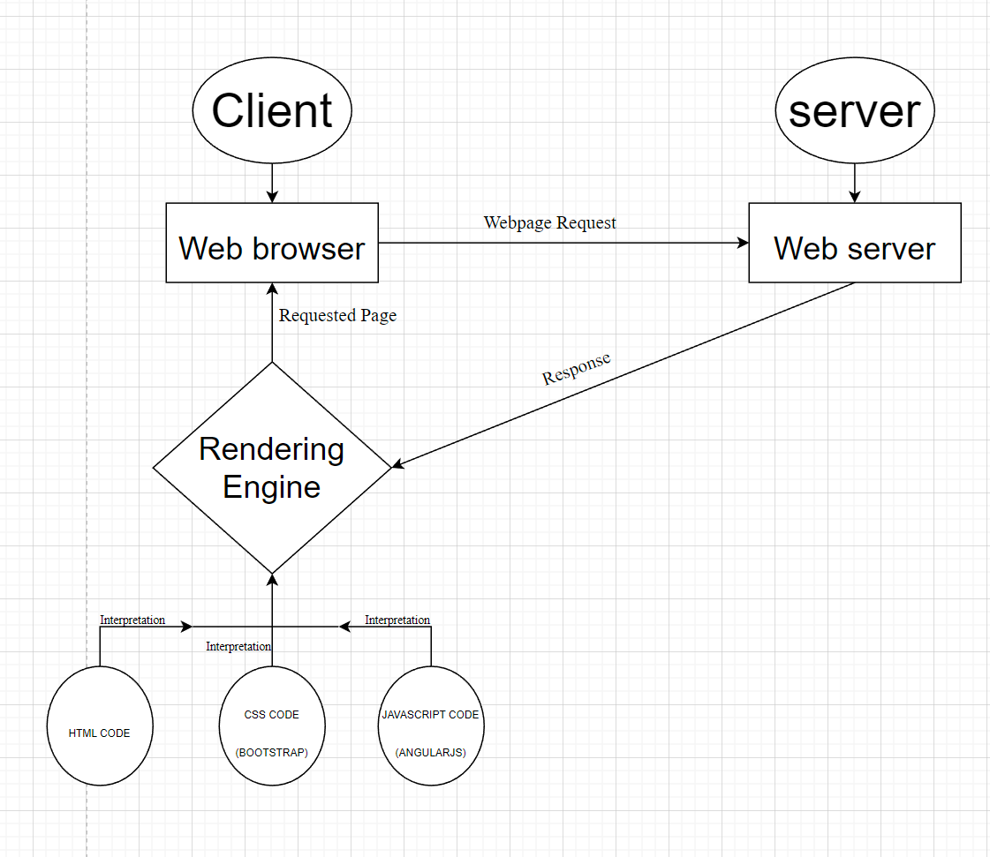

# 

# DIAGRAM OF THE WEBSITE

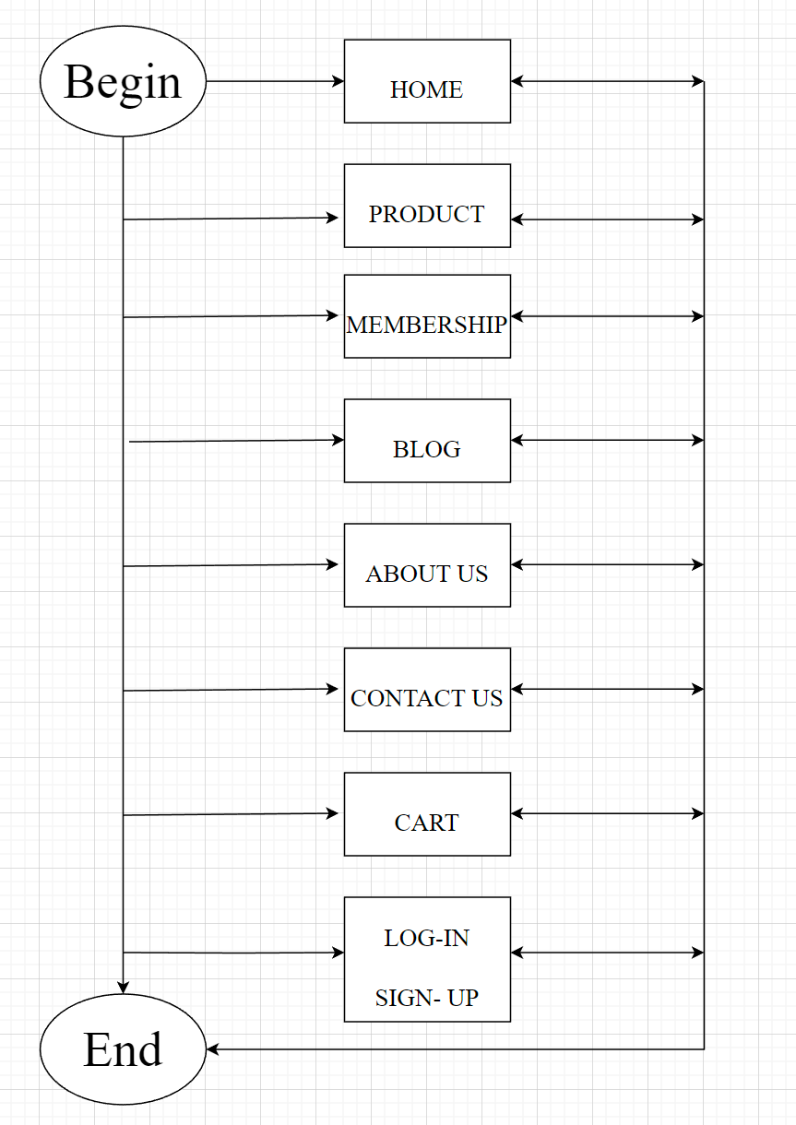



# TASK SHEET REVIEW 1

|  |  |  |  |  |  |  |  |
| --- | --- | --- | --- | --- | --- | --- | --- |
| **Project Ref. No.:**  **eP/Advertisement Portal Management**  **System/01** | | **Project Title:** | **Activity Plan Prepared By:** | **Date of Preparation of Activity Plan:** | | | |
| **Sr.**  **No.** | **Task** | **Actual**  **Start**  **Date** | **Actual Days** | **Team**  **Mate Names** | **Status** |
| 1 | Problem Statement | RHYTHM  HOUSE | An | 14-Nov-22 | 1 | Khuong | Completed |
| 2 | Analysis of Rhythm House requirements about the website | 14-Nov-22 | 1 | Khuong | Completed |
| 3 | The scope of the work | 14-Nov-22 | 1 | An | Completed |
| 4 | Architecture and design of the system | 14-Nov-22 | 1 | An | Completed |
| 5 | Diagram of the website | 14-Nov-22 | 1 | An | Completed |
| 6 | Task Sheet | 14-Nov-22 | 1 | An | Completed |

|  |  |
| --- | --- |
| **Date:** | |
| Signature of Instructor:  **Ms. Le Mong Thuy** | Signature of Team Leader:  **Nguyen Trinh Duy An** |

# SITE MAP

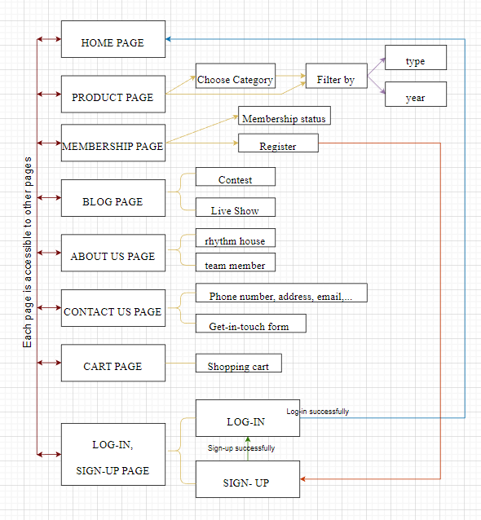

# MOCK OF THE WEB SITE

1. **Homepage**

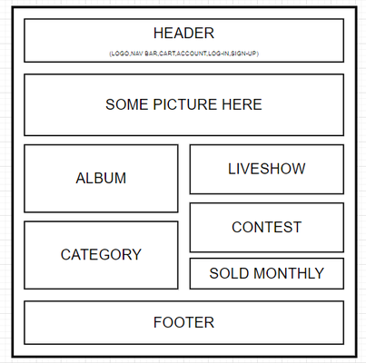

1. **Product**

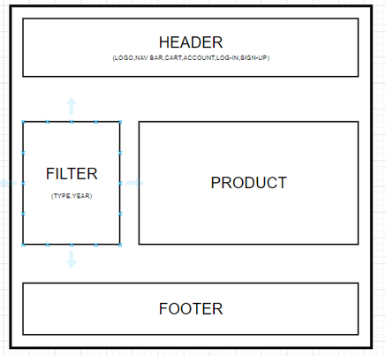

1. **Membership**

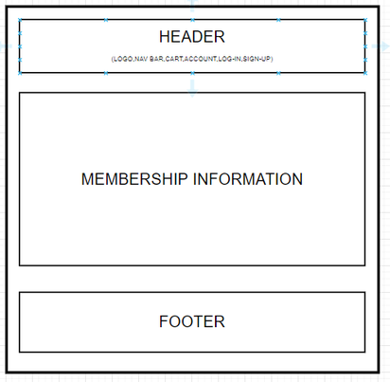

1. **Blog**

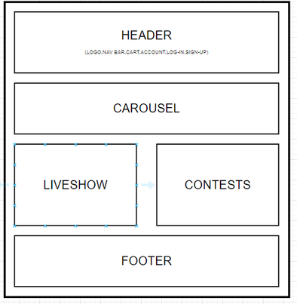

1. **About Us**

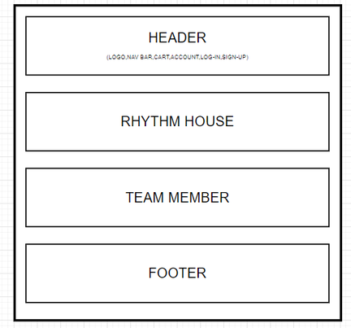

1. **Contact Us**

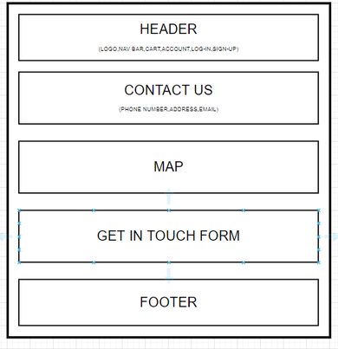

1. **Service**

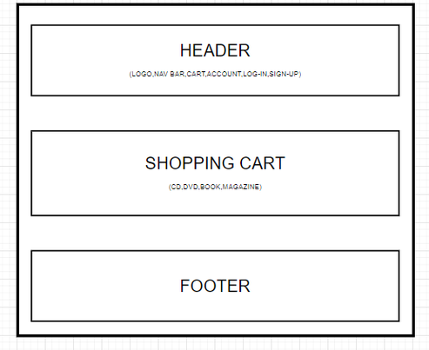

1. **Log In, Sign Up**

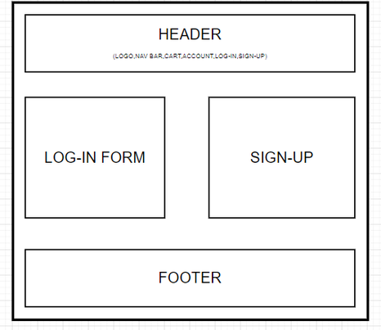

# TASK SHEET REVIEW 2

|  |  |  |  |  |  |  |  |
| --- | --- | --- | --- | --- | --- | --- | --- |
| **Project Ref. No.:**  **eP/Advertisement Portal Management**  **System/01** | | **Project Title:** | **Activity Plan Prepared By:** | **Date of Preparation of Activity Plan:** | | | |
| **Sr.**  **No.** | **Task** | **Actual**  **Start**  **Date** | **Actual Days** | **Team**  **Mate Names** | **Status** |
| 1 | Site Map | RHYTHM  HOUSE | An | 16-Nov-22 | 1 | An | Completed |
| 2 | Mock of the website | 16-Nov-22 | 2 | Khuong | Completed |
| 3 | Task sheet | 18-Nov-22 | 1 | An | Completed |

|  |  |
| --- | --- |
| **Date:** | |
| Signature of Instructor:  **Ms. Le Mong Thuy** | Signature of Team Leader:  **Nguyen Trinh Duy An** |

# WEBSITE DESCRIPTION

1. **Homepage**
2. Description

Home page displays following information:

- Slide show programs. (carousel function)

- Upcoming live shows, contest.

- Popular categories.

- Albums.

- Statistics sold monthly.

1. **Product**
2. Description

This product page displays following information:

- Clicking on the product filter will show detailed information

- Products can be filtered by category, type or year..

- Menu section can easily be found items based on categories.

- The product page also has a search function. This product page displays following information:

- Clicking on the product filter will show detailed information

- Products can be filtered by category, type or year.

- Menu section can easily be found items based on categories.

- The product page also has a search function.

1. Screen shot
2. **Membership**
3. Description

The membership page displays following information:

- Point Calculation.

- A registry button.

1. **Blog**
2. Description

The blog page displays following information:

- Liveshow.

- Contests.

1. - Carousel.**About Us**
2. Description

- This page displays information about the history of Rhythm House, our service that we provide and our team member.

- Display information about members that build this website.

1. **Contact Us**
2. Description

- This page displays contact information: map, phone number, address,email and a get in touch form for customer

- When submitting the form successfully, the message is displayed

1. **Cart**
2. Description:

- Display choosen items.

- There are delete and order button.

1. **Login/ Signup**
2. Description

This page displays information:

- Log-in form and sign-up form.

- To register users need to enter name, phone number and email. After submitting the user will return to the homepage

- To login user need to enter username and password. After submitting the user will return to the homepage.

This page displays information:

- Log-in form and sign-up form.

- To register users need to enter name, phone number and email. After submitting the user will return to the homepage

- To login user need to enter username and password. After submitting the user will return to the homepage.

**RESPONSIVE**

The page has responsive feature for small screen device such as smart phone, tablet, etc.

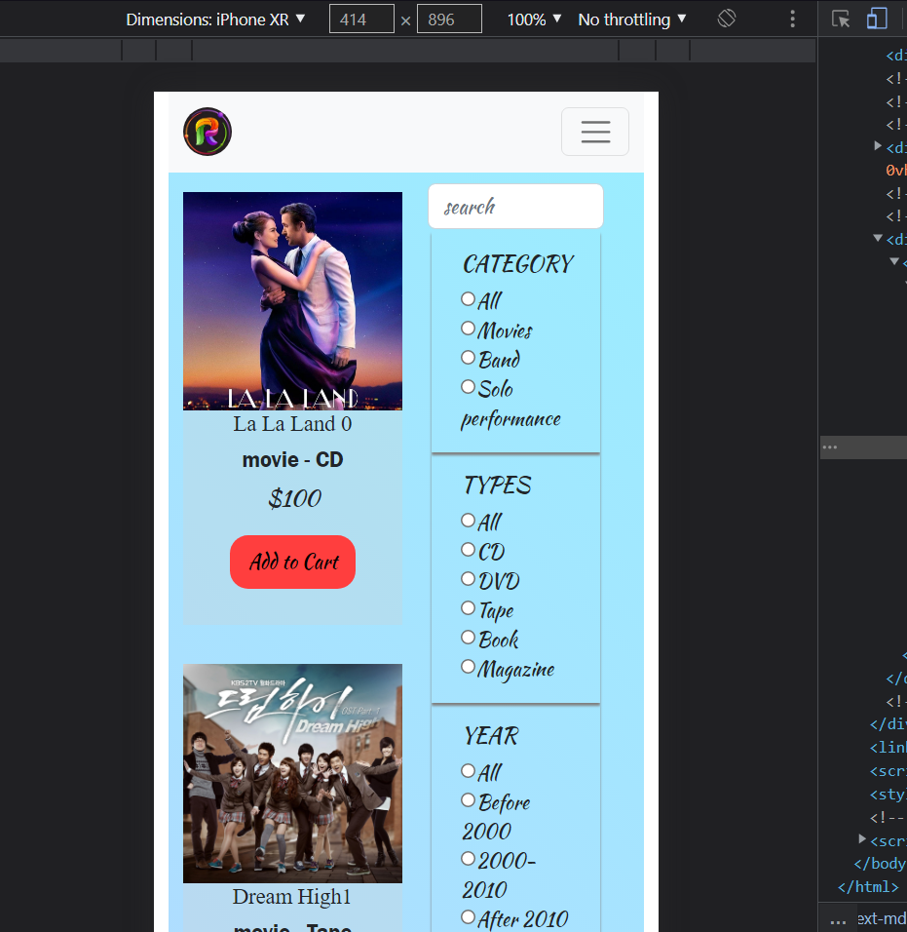

# TASK SHEET REVIEW 3

1. **Home**

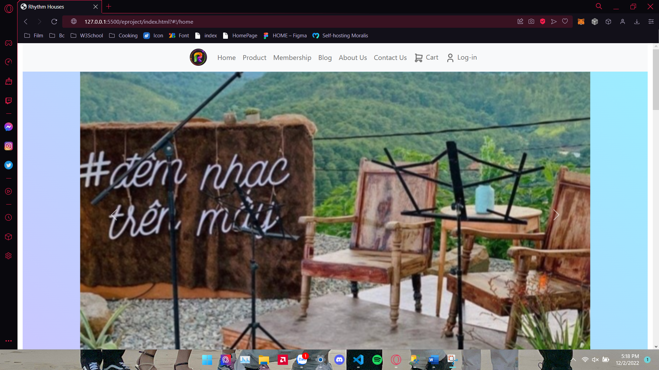

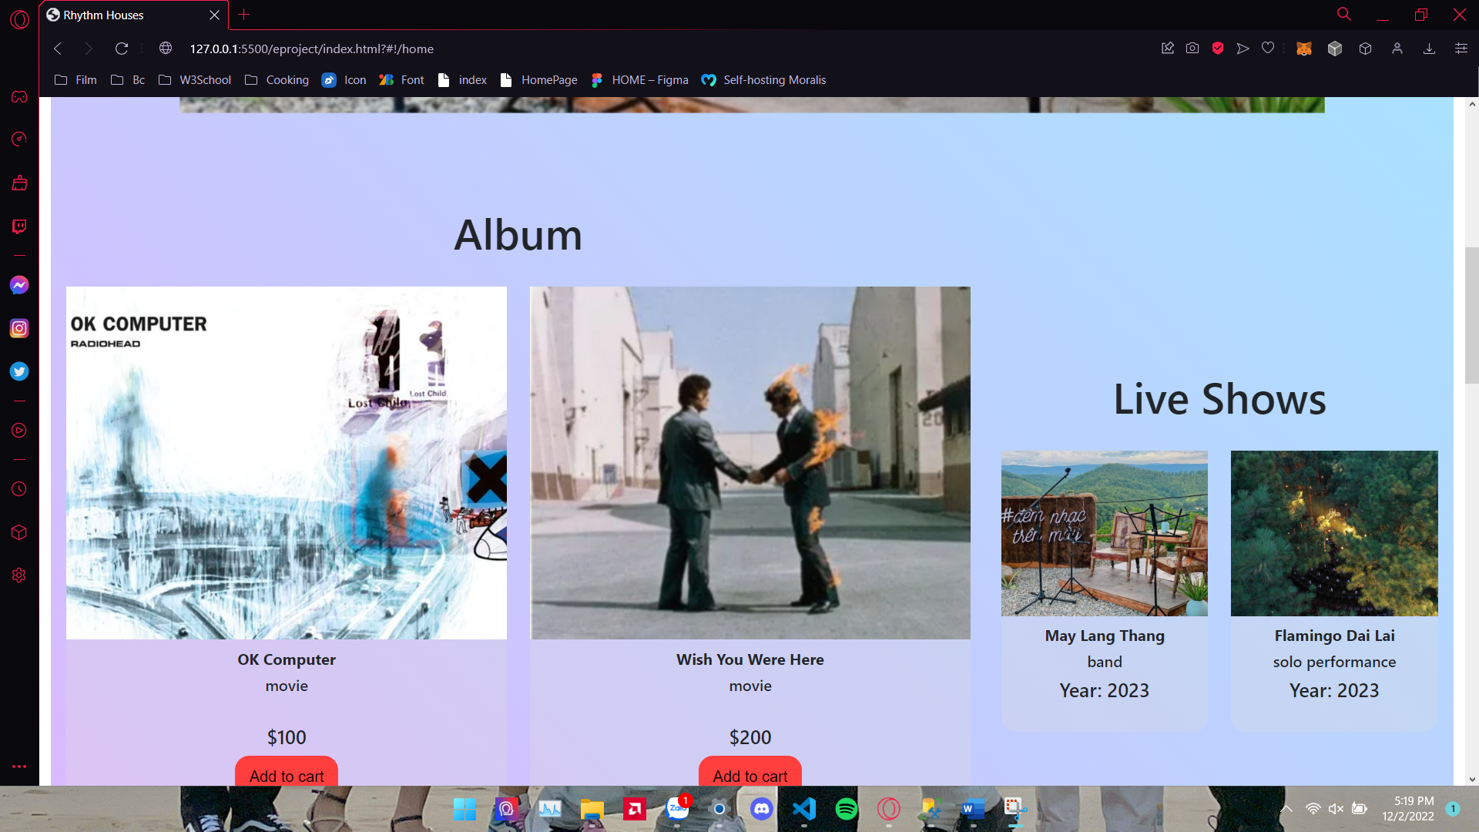

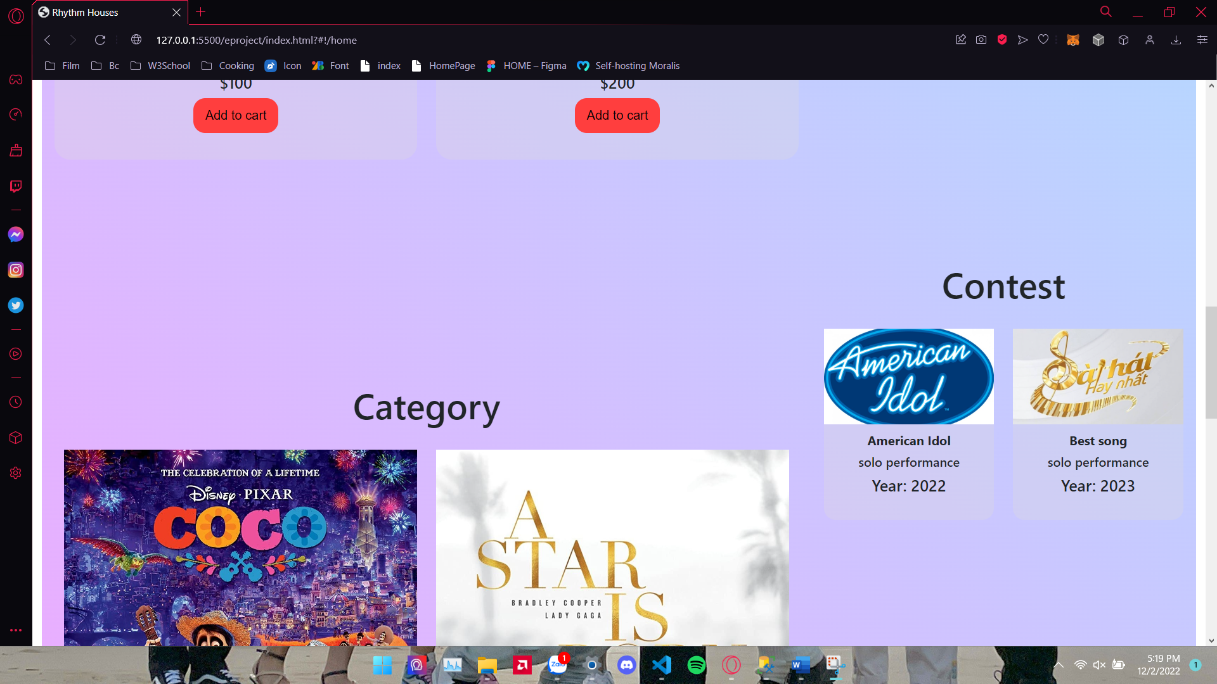

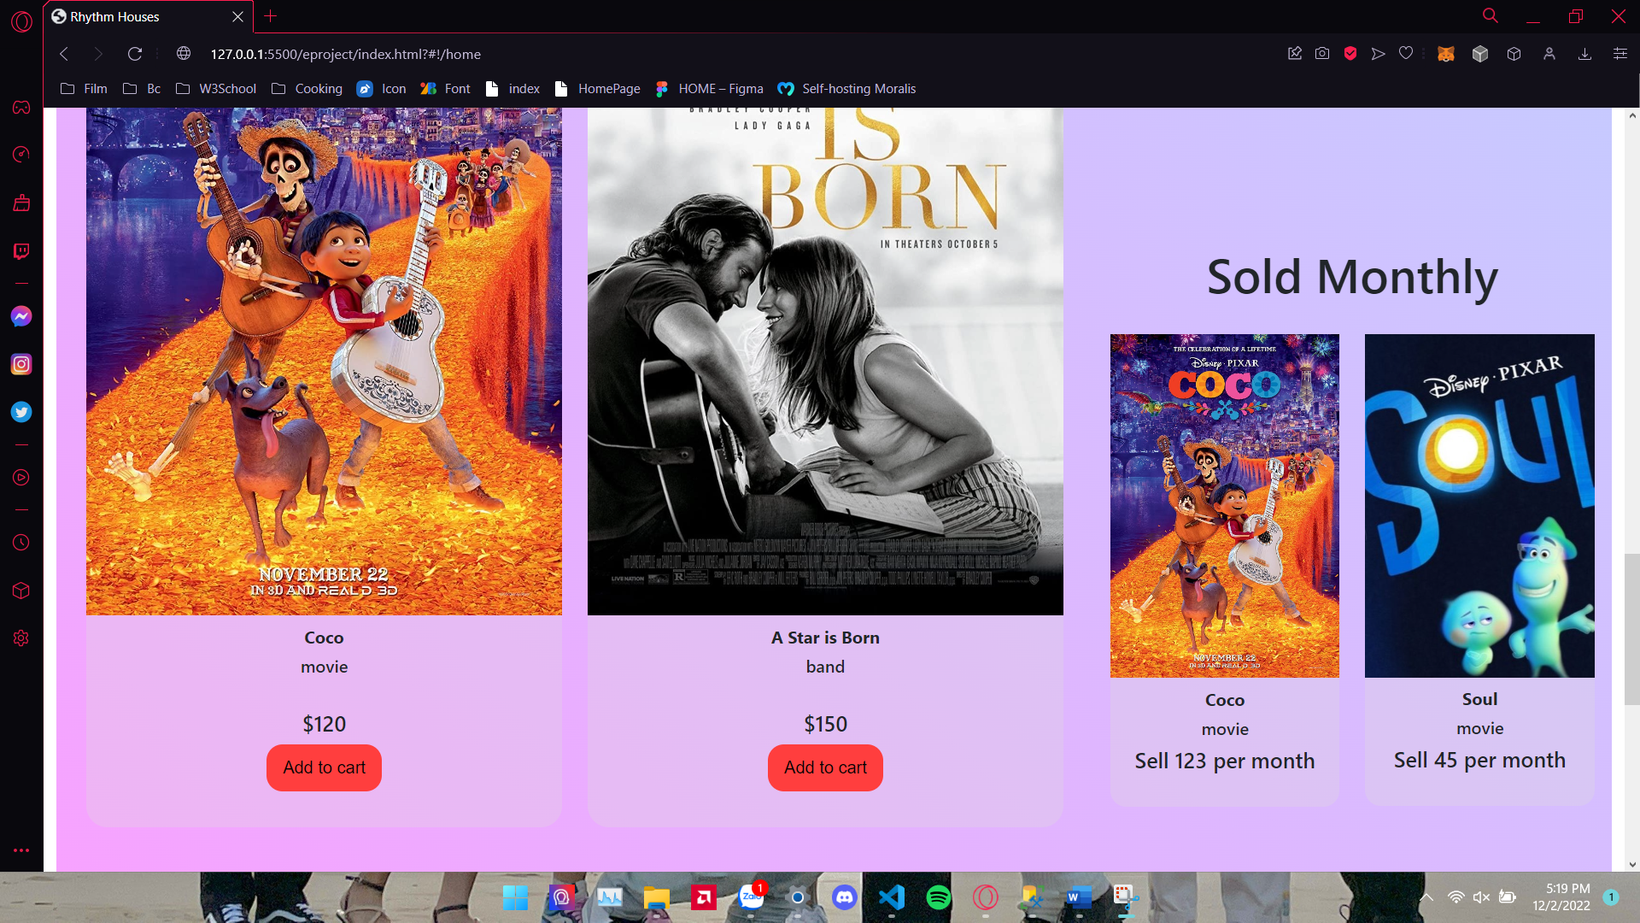

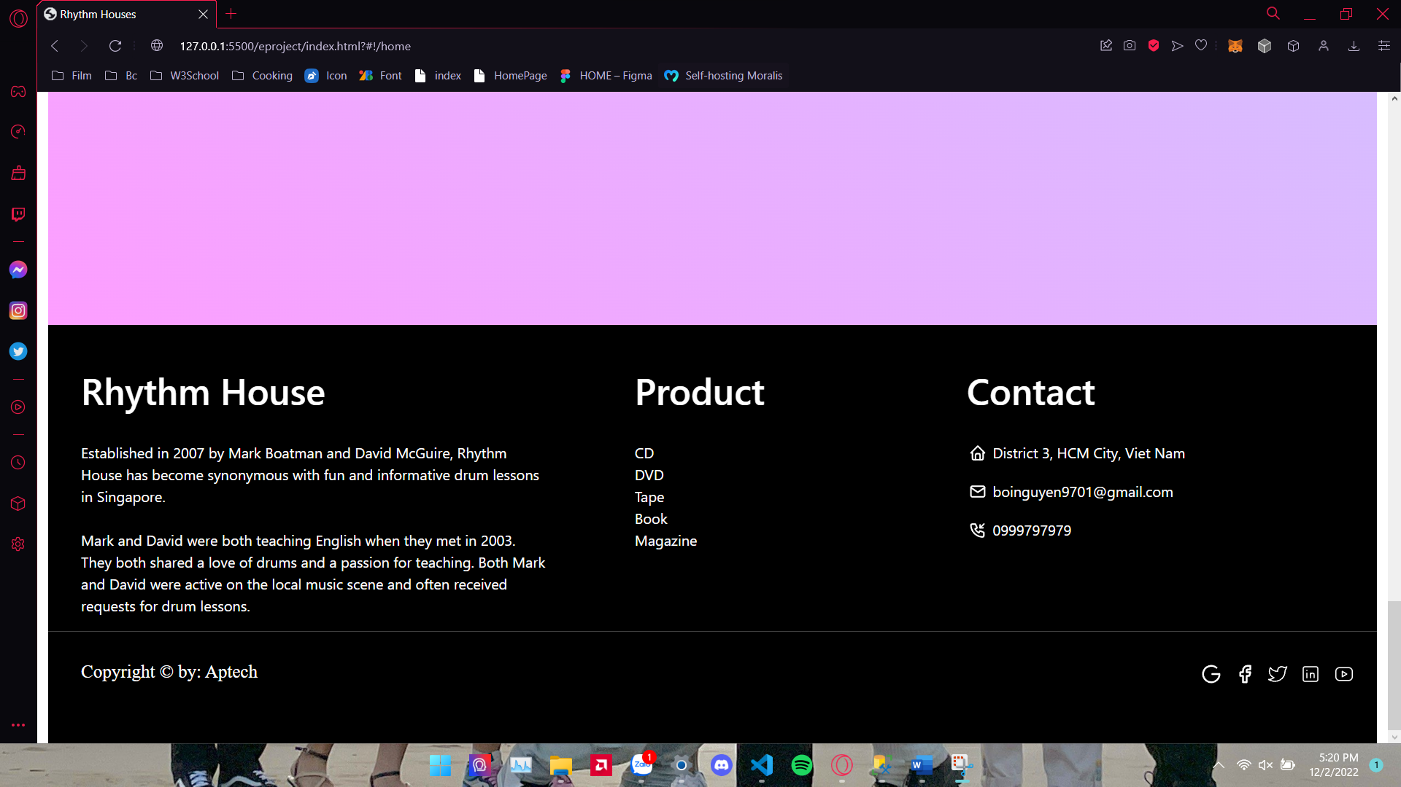

1. **Product**

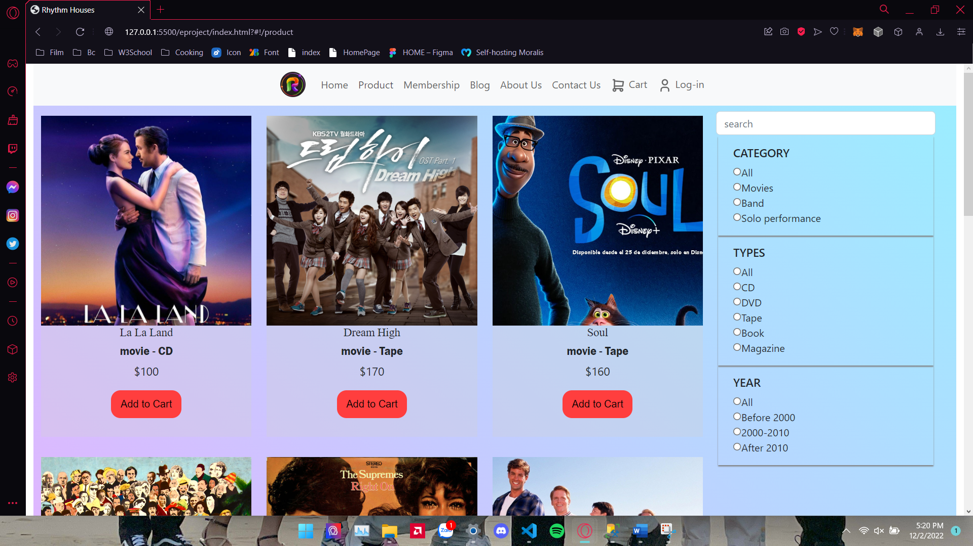

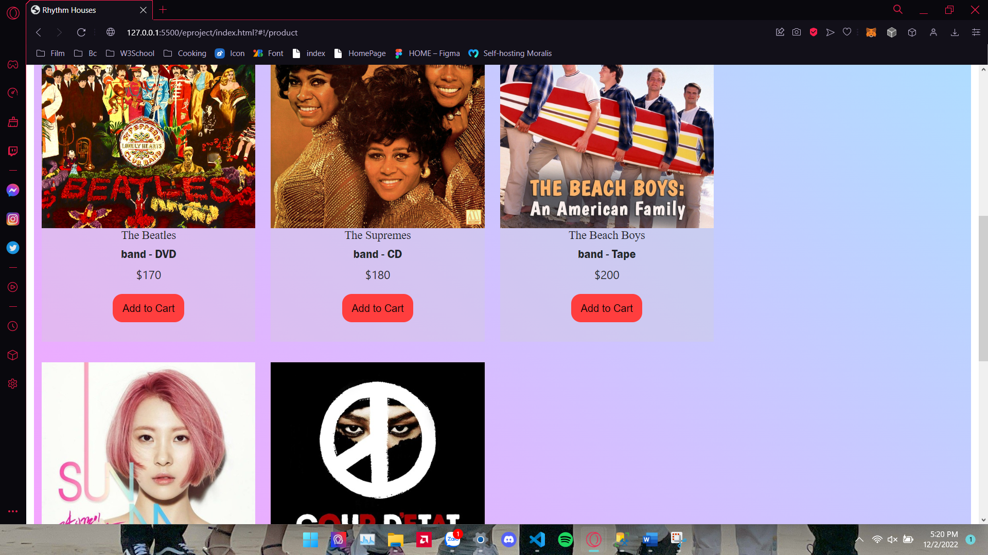

1. **Membership**

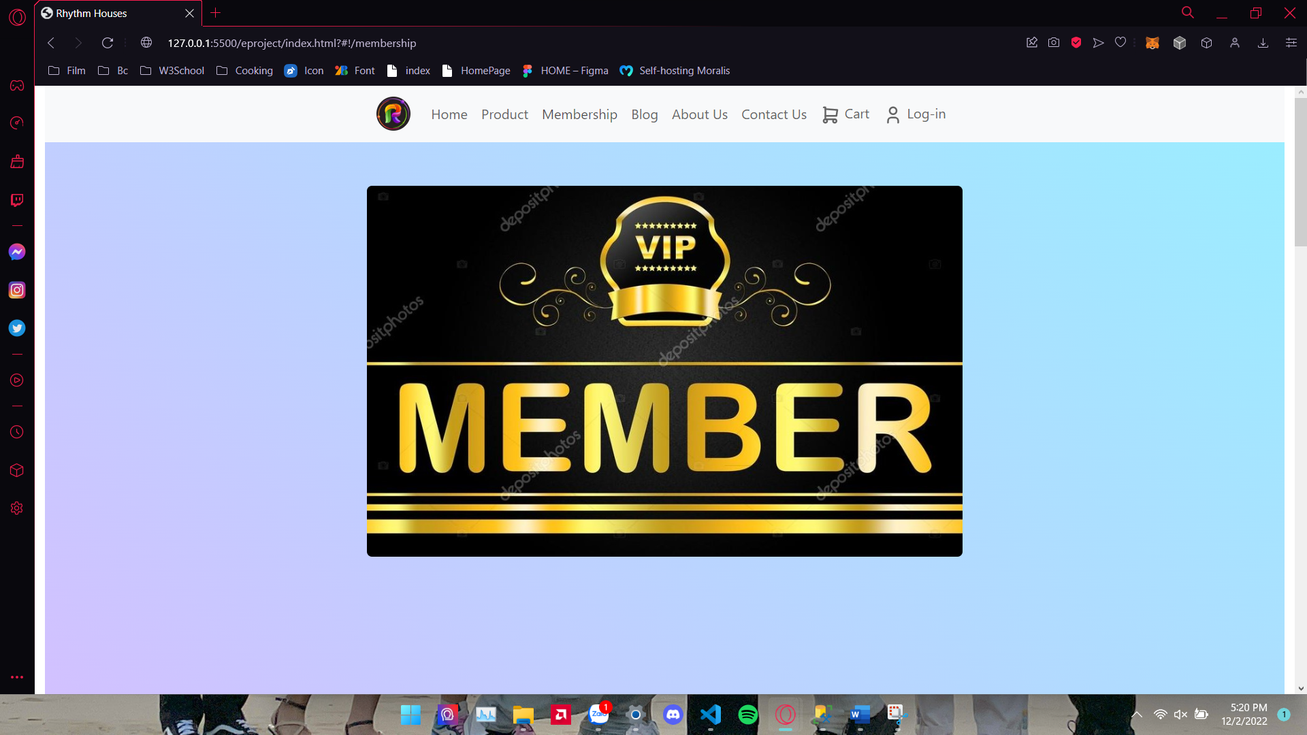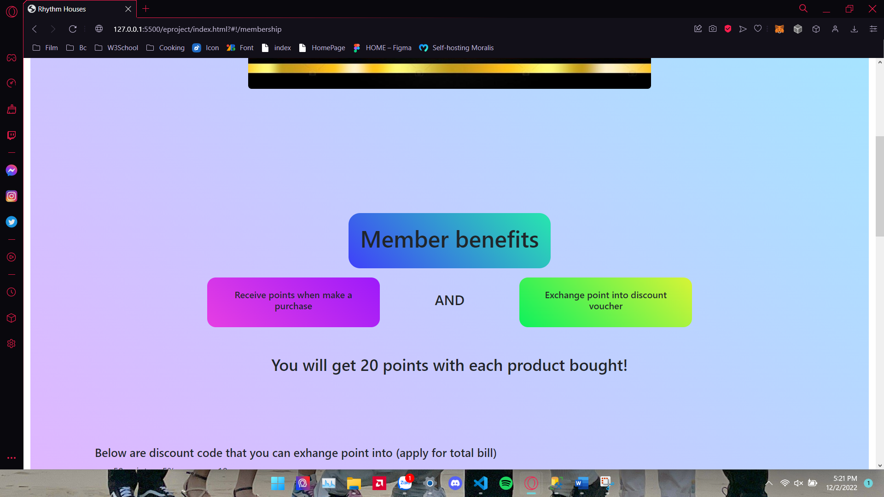

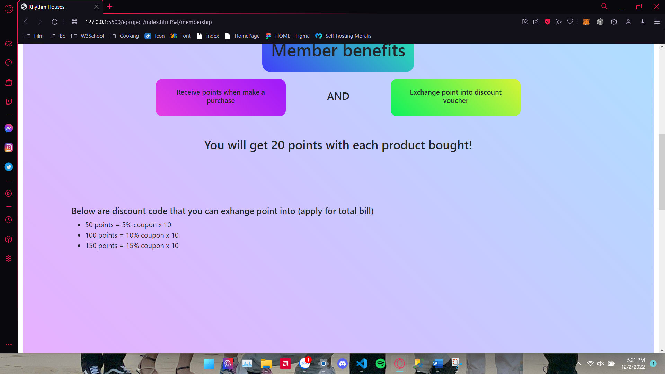

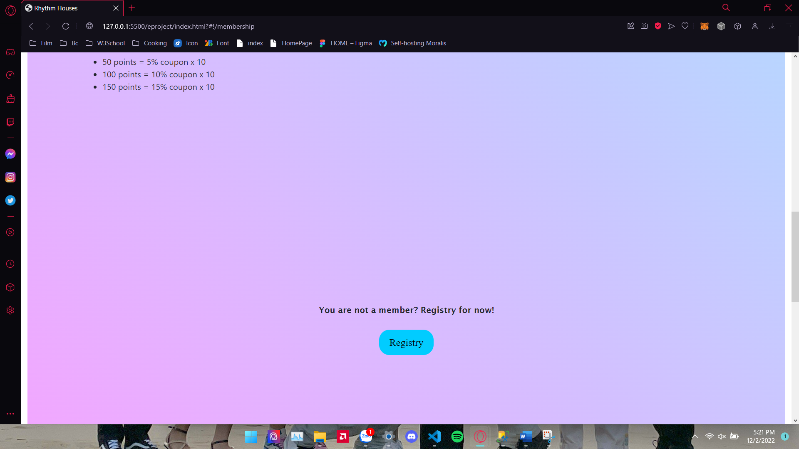

1. **Blogs**

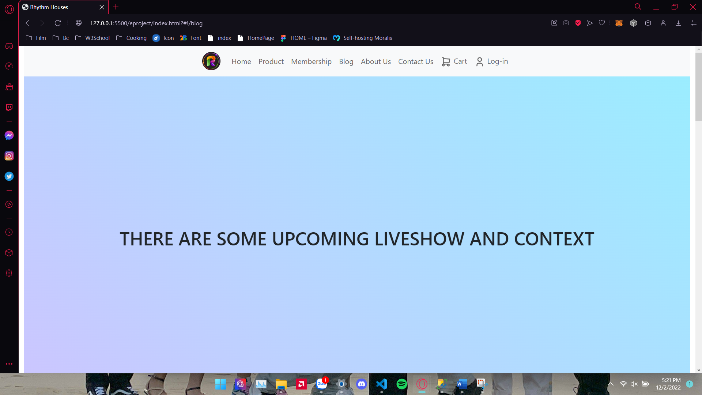

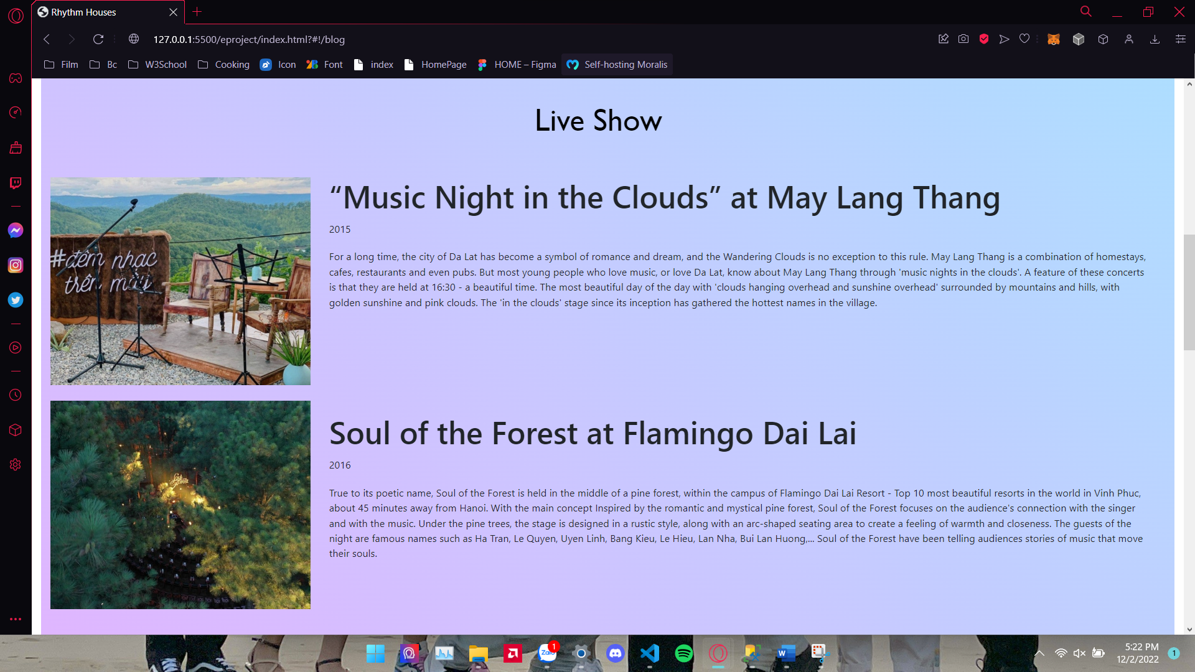

1. **About Us**

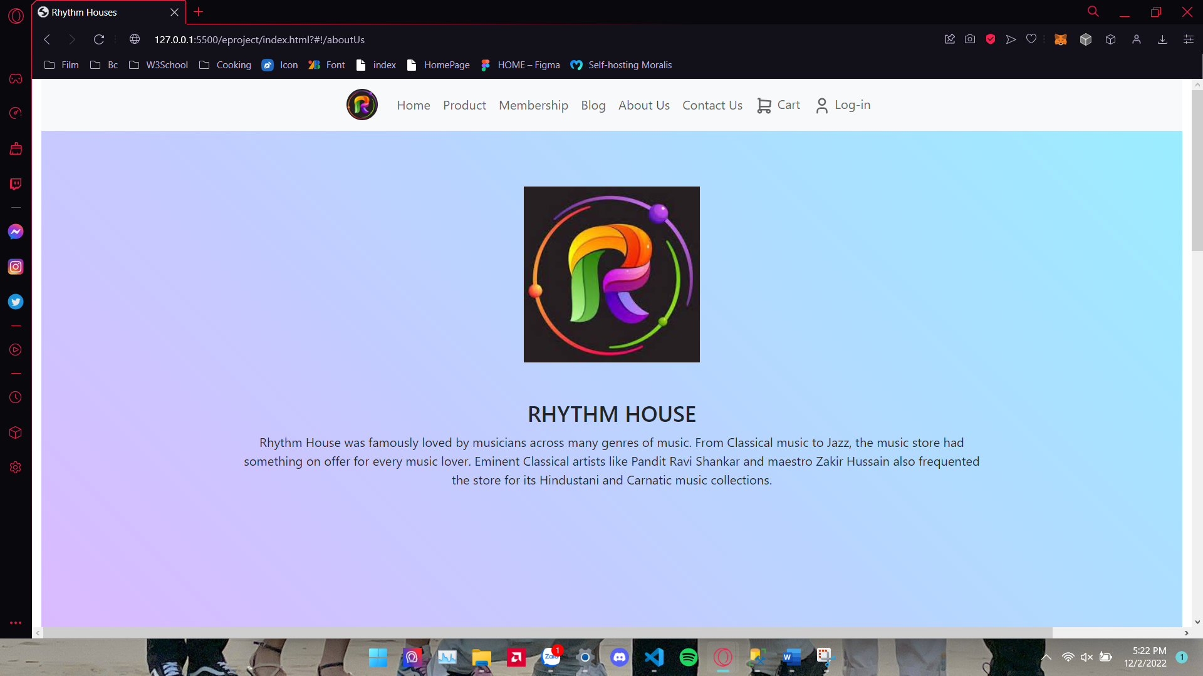

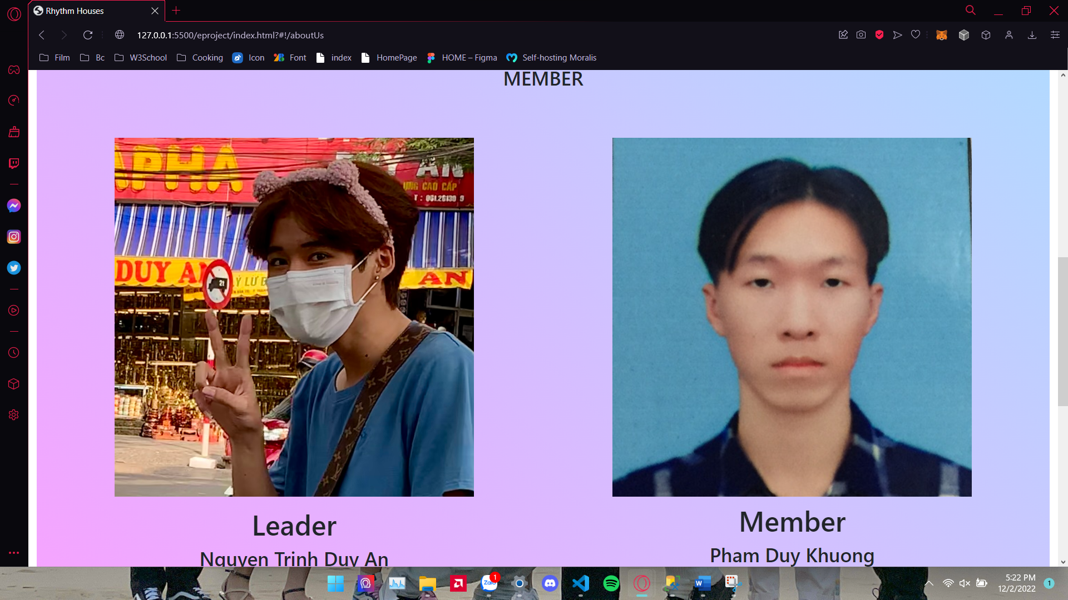

1. **Contact Us**

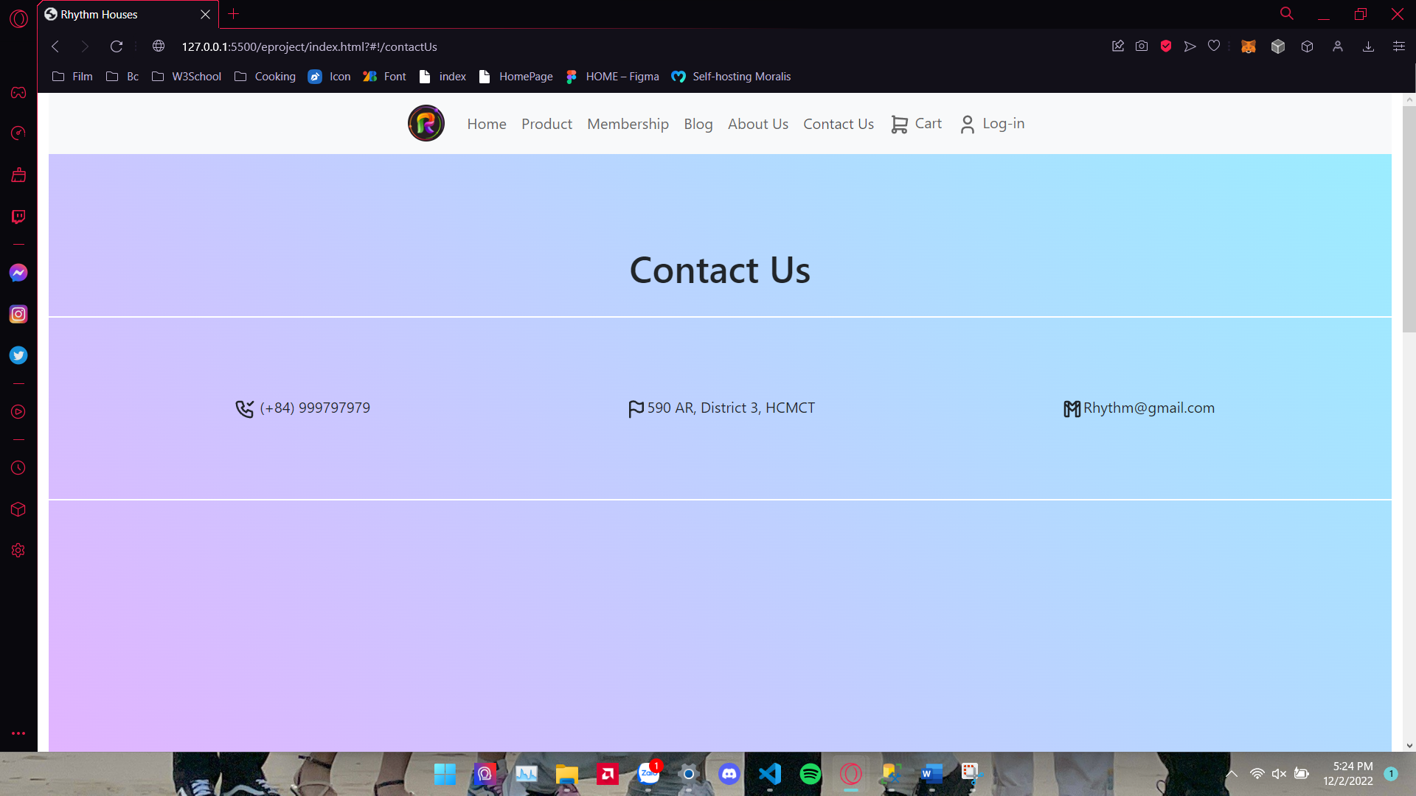

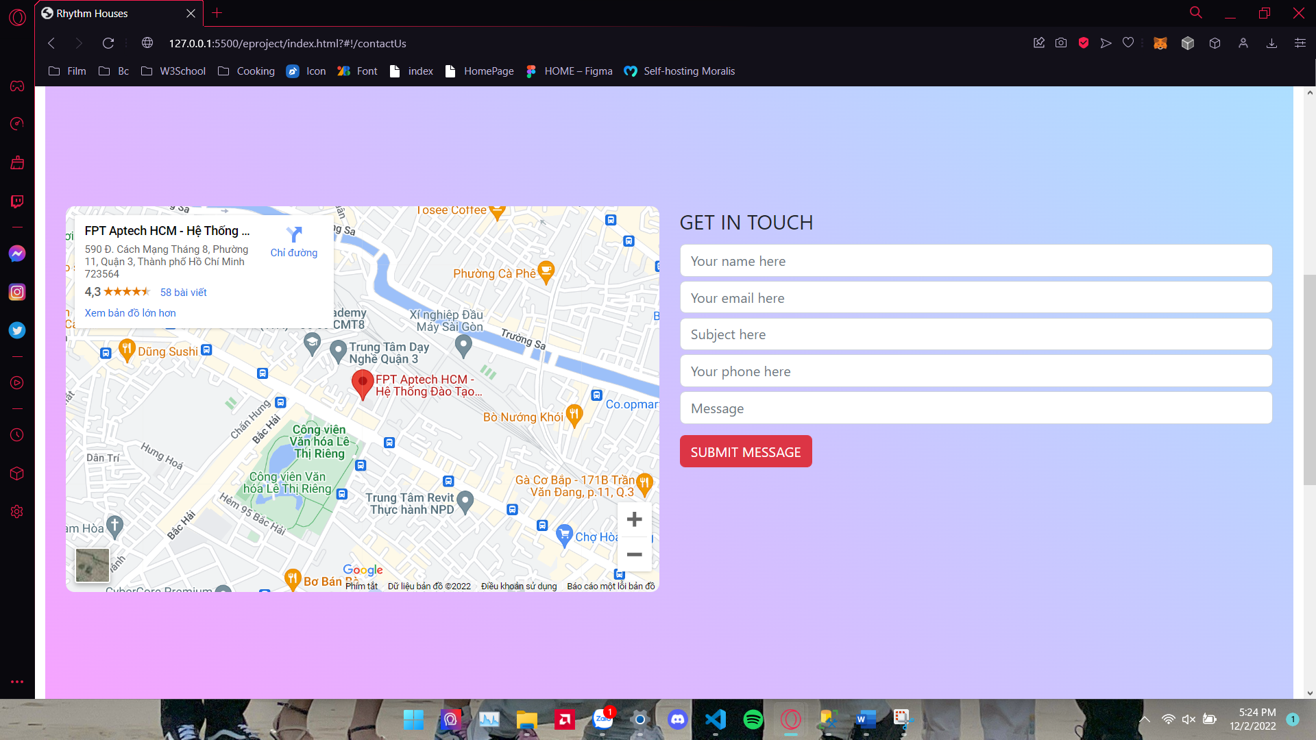

1. **Cart**

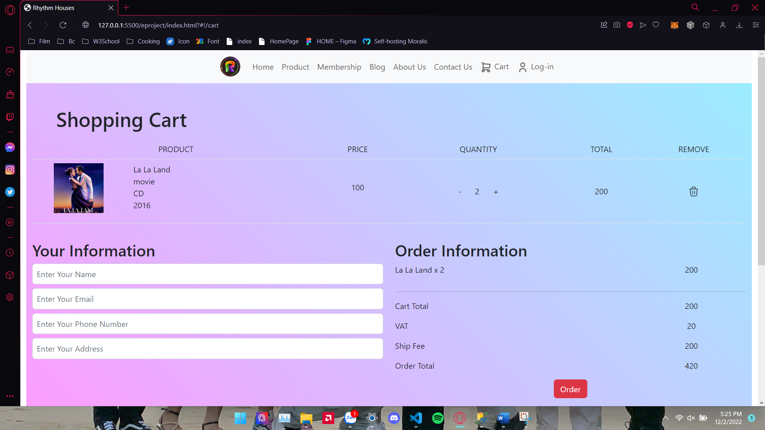

1. **Log-in Sign-up**

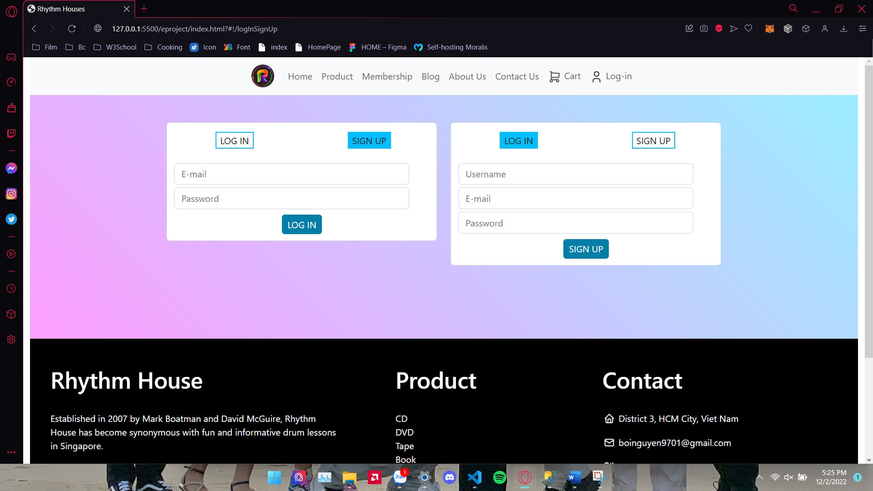

|  |  |  |  |  |  |  |  |
| --- | --- | --- | --- | --- | --- | --- | --- |
| **Project Ref. No.:**  **eP/Advertisement Portal Management**  **System/01** | | **Project Title:** | **Activity Plan Prepared By:** | **Date of Preparation of Activity Plan:** | | | |
| **Sr.**  **No.** | **Task** | **Actual**  **Start**  **Date** | **Actual Days** | **Team**  **Mate Names** | **Status** |
| 1 | Home Page | RHYTHM  HOUSE | An | 19-Nov-22 | 2 | An | Completed |
| 2 | Product | 19-Nov-22 | 2 | Khuong | Completed |
| 3 | Membership | 21-Nov-22 | 2 | An | Completed |
| 4 | Blog | 21-Nov-22 | 2 | Khuong | Completed |
| 5 | About Us | 23-Nov-22 | 2 | An | Completed |
| 6 | Contact Us | 23-Nov-22 | 4 | Khuong | Completed |
| 7 | Cart | 25-Nov-22 | 2 | An | Completed |
| 8 | Sign In/ Sign Up | 27-Nov-22 | 2 | Khuong | Completed |
| 9 | Responsive | 27-Nov-22 | 2 | An | Completed |

|  |  |
| --- | --- |
| **Date:** | |
| Signature of Instructor:  **Ms. Le Mong Thuy** | Signature of Team Leader:  **Nguyen Trinh Duy An** |